SmartEverything Design Doc

# Use cases

## CDC Use Case

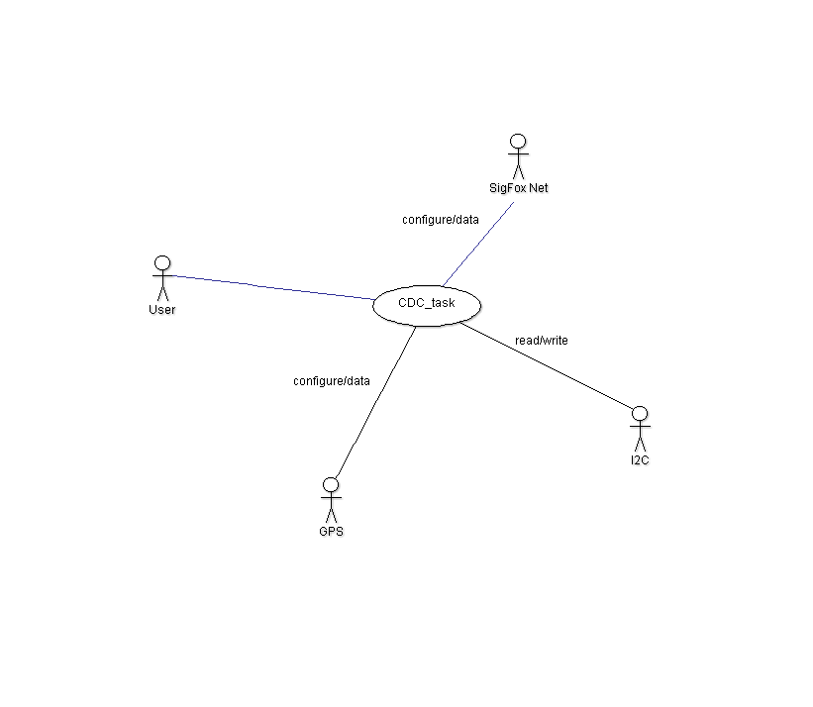

Figure - CDC Use Case

This use case cover the interaction between the console and all the Hw elements are present on the SmartEverything board.

It is useful to test the components and to send specific command not covered by the application itself.

The components are divided in 2 main group, according with their communication interface:  
UART  
I2C

All those components are under the I2C will be addressed by the specific address

All those are under UART will be address by a specific command

I2C Command:

i2c <address> [r/w] <register> <data> */

address = the I2C address of the component to drive  
R/W = R read from a register w write to a register  
register = the register where the user wants r/w  
data = valid only in w case, it is the data want to write to the register

UART:

SigFox:

sf <c/d> [r/w] <register> <data>

c = move the sigfox in configuration mode (basically send "+++"

d = move the sigfox in data mode (basically send "ATS220=23" or "ATX")

CONFIGURATION MODE = sf c r/w <register> <data>

Valid only in configuration mode

r = read register

w = write register

register = the register in DEC mode

data = the value to write on the register (only in conf w mode)

sending "sf c" (without parameters) move the sigfox in configuration mode

DATA MODE = sf d <type> <data>

type = could be one of the following value

DATA: simple data

KEEP: used to send a keep alive message as described in the SIGFOX standard;

it’s in charge to the user to send the keep alive message every 24 hours

BIT: send a status bit following the SIGFOX protocol

data = could be one of the following value according with the type assigned

DATA: up to 255 bytes

KEEP: must be omitted

BIT: one byte with value 0 or 1

sending "sf d" (without parameters) move the sigfox in data mode

## tasks

## User interaction Use Case

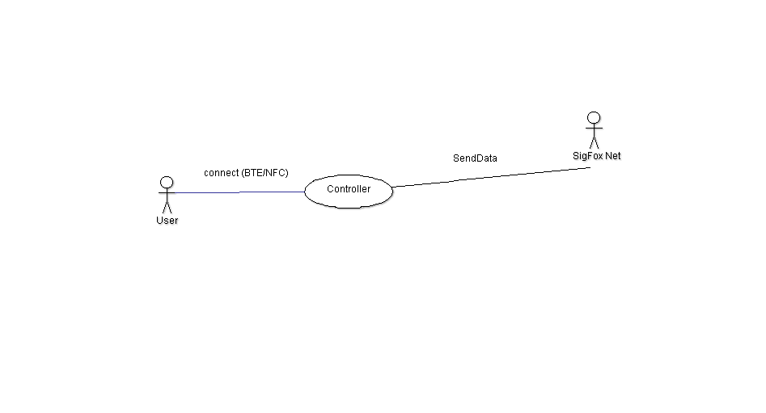

## tasks